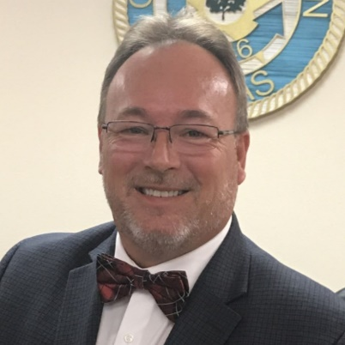
My name is Lonnie E. Gosch and I am a Republican candidate for County/District Attorney of Milam County. I have proudly spent most of my life in the humble service of the citizens of Milam County, since 1995.
My career in criminal justice began in 1993 as a Municipal Police Officer. In 1995, I joined the Milam County Sheriff’s Department. During my time as a Sheriff’s Deputy, I knew I could do more for the citizens of Milam County and toward that end, I returned to college while continuing to work full-time as a Milam County Deputy Sheriff. After earning my bachelor’s degree in criminal justice from Sam Houston State University, I earned my law degree from South Texas College of Law in 2003. In 2006, I resigned as a Deputy Sheriff and began a full time, general law practice representing clients in Robertson and Milam Counties primarily, but throughout the State of Texas. I returned to full-time law enforcement as the Chief of Police for the City of Cameron in 2017.
I seek the position of Milam County District Attorney with purpose, to make Milam County—my home—a safe and secure community for its citizens and promote equality under the law. As your District Attorney, I will work tirelessly to strengthen Milam County’s criminal justice system through cooperative law enforcement, equality in justice, and fierce prosecution of crimes. As a peace officer, an attorney and current Chief of Police for the City of Cameron, I have a working, front line, hands on experience with law enforcement, the courts, and the citizens of Milam County. I will ensure meaningful prosecution of cases and faithful representation of the citizens of this County with professionalism, honesty and integrity.
As an honorably discharged infantry veteran with 26 years of law enforcement experience and 16 years of civil and criminal experience as an attorney, I offer a unique, working knowledge of all aspects of the criminal justice system and the people it is meant to serve. I am intimately familiar with the support our law enforcement and community needs. There is simply no candidate with the skills, “hands on” experience, and perspective that I offer. I will promote the equality and strength in justice this community so richly deserves and provide Milam County a District Attorney to be proud of. I humbly and respectfully ask for your vote and support in the Republican Primary as we move forward to a brighter, safer future for Milam County and its citizens.

